Name: Yadnesh Patil
PRN:123B1D034
Assignment no:09

- Consider each document in the zipcode collection has the following form:
{
"_id": "10280",
"city": "NEW YORK",
"state": "NY", "pop": 5574,
}
Return States with population above 10 Million
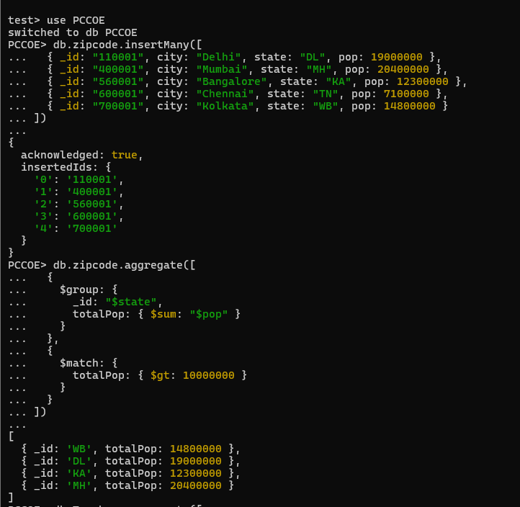

- Display the department wise average salary
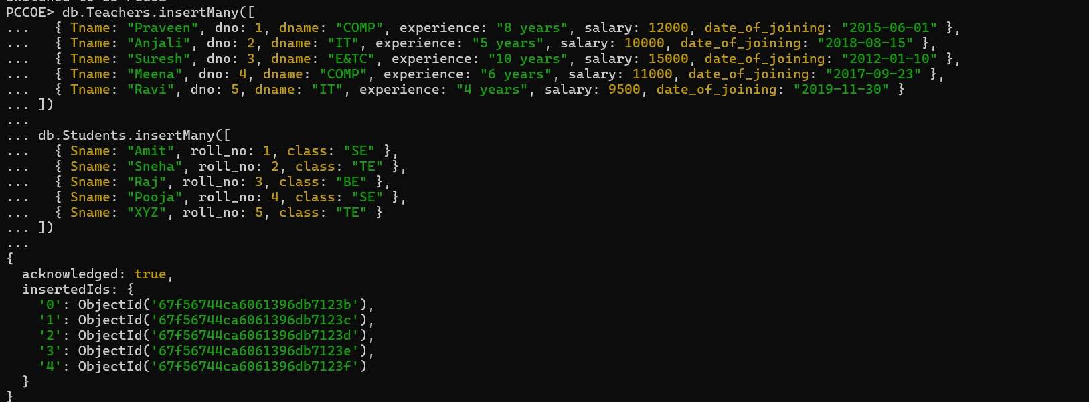
- display the no. Of employees working in each department
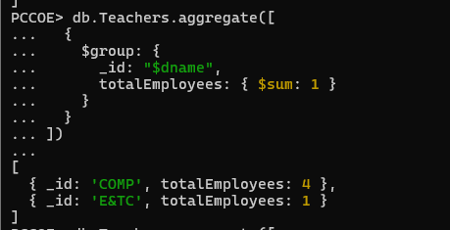

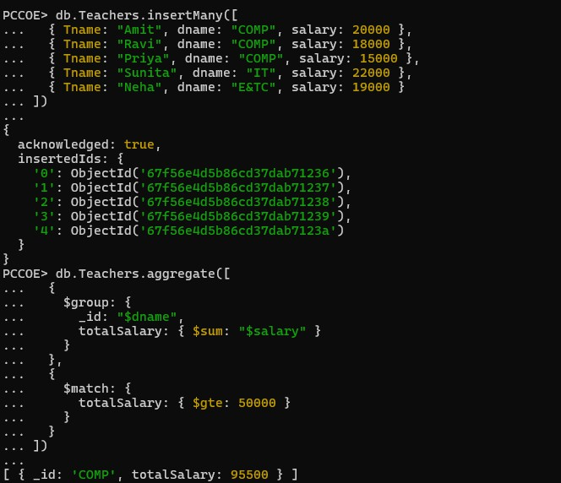
- Display the department wise total salary of departments having total salary greater than or equals to 50000/-
- Write the queries using the different operators like max, min. Etc.
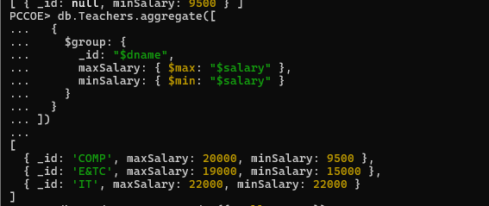

- Create the simple index on roll_no field
- create unique index on any field for above given collections
- create compound index on any fields for above given collections
- Show all the indexes created in the database PCCOE
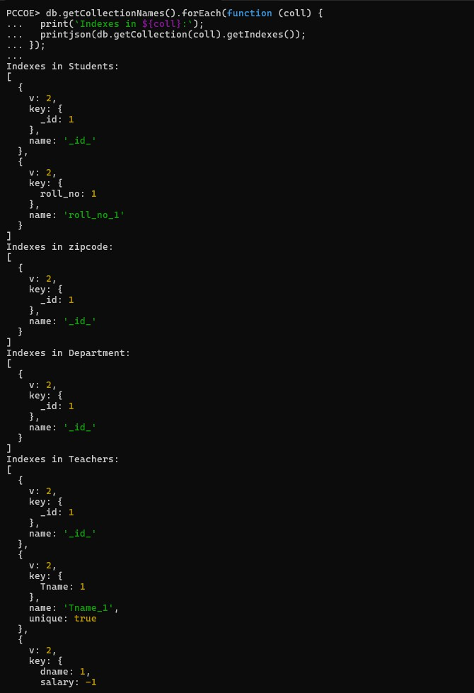
- Show all the indexes created in Teachers collections.

